Team Sayash

🛵B.R.A.S.R.✅

Bitmasking Recursive Appointment Scheduling and Routing

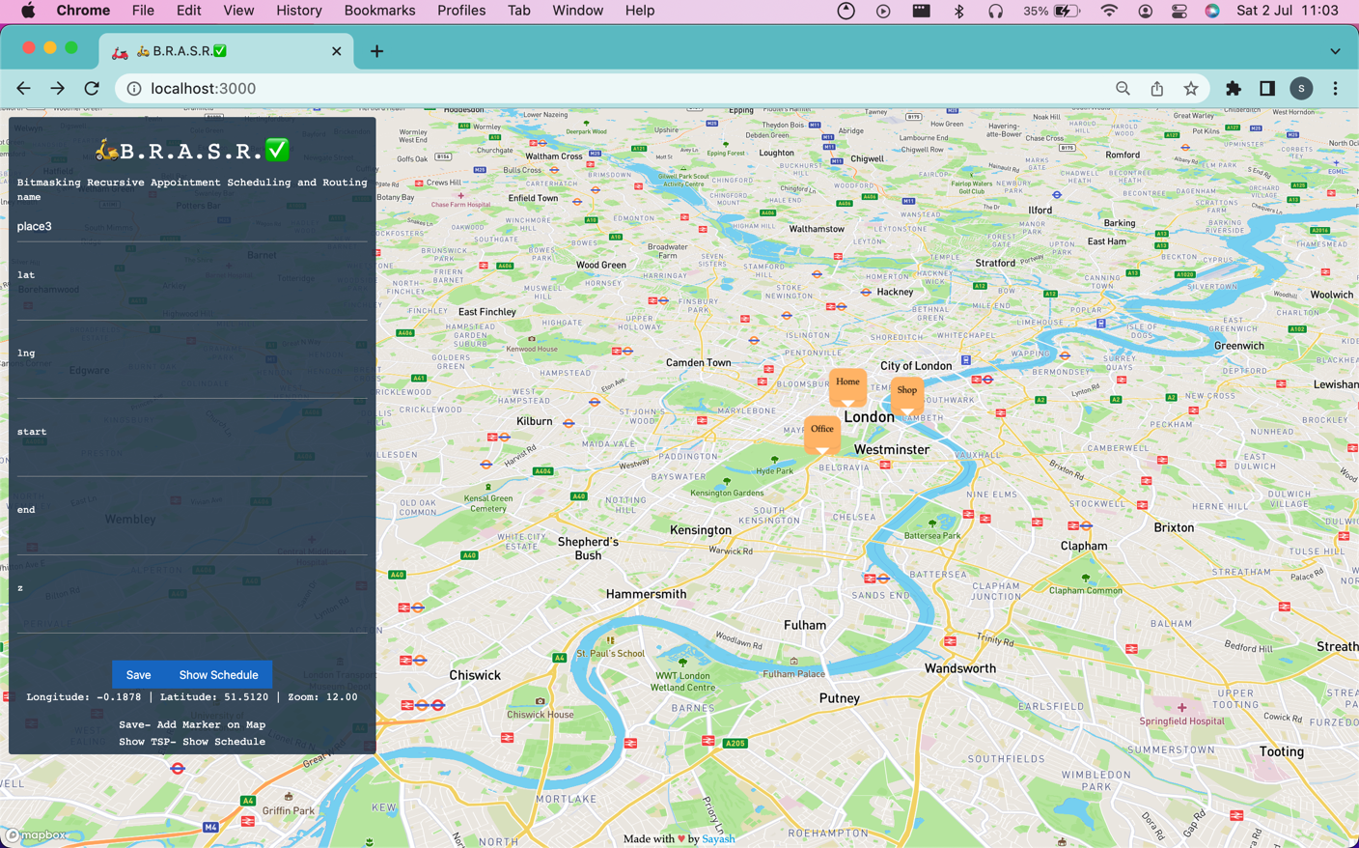

# Github Documentation

* Deliverables
* GitHub Configuration
* Working
* Example JSON Request and JSON Response
* API model
  + API scheduling
  + API Calendar (Outlook, Google Calendar, etc. all calendars) integration
* UI integration
  + UI input scheduling
  + Maps integration
  + UI Calendar (Outlook, Google Calendar, etc. all calendars) integration

EXL Hackathon- building solutions for larger challenges faced by insurance companies; solutions that fulfill the needs of consumers; solutions that improve customer experience

Theme- Create a solution for Appointment Scheduling and Routing

Appointment scheduling and routing solution helps in reducing manual, time-taking processes such as maintaining data. security, etc.

This solution helps in tracking locations and addresses. It has been integrated successfully with online maps to improve efficiency, which is not possible in a manual offline process.

* **Minimum task DONE** ✅
  + Build a restful API to schedule and confirm appointments based on the description mentioned DONE ✅
  + An interface to clearly see the agenda/calendar for the day with the drive time between appointments DONE ✅
  + Integration with Outlook/Teams calendar DONE ✅
* **Intermediate task DONE** ✅
  + Create a smart solution rearranging the appointments to reduce drive time DONE✅
* **Advanced task DONE** ✅
  + Integration with Teams or Outlook to reflect the agenda DONE ✅

Tech Stack

* REST API
* Frontend Framework
* Custom-built scheduling and routing algorithm
  + Uses a 32-bit Bitmasking Recursive approach using an NP-hard solution framework
  + Recursively finds the shortest path w.r.t time with given constraints
  + Uses graph-algorithmic approach
  + Uses bitmasking to store mid-execution state of algorithm

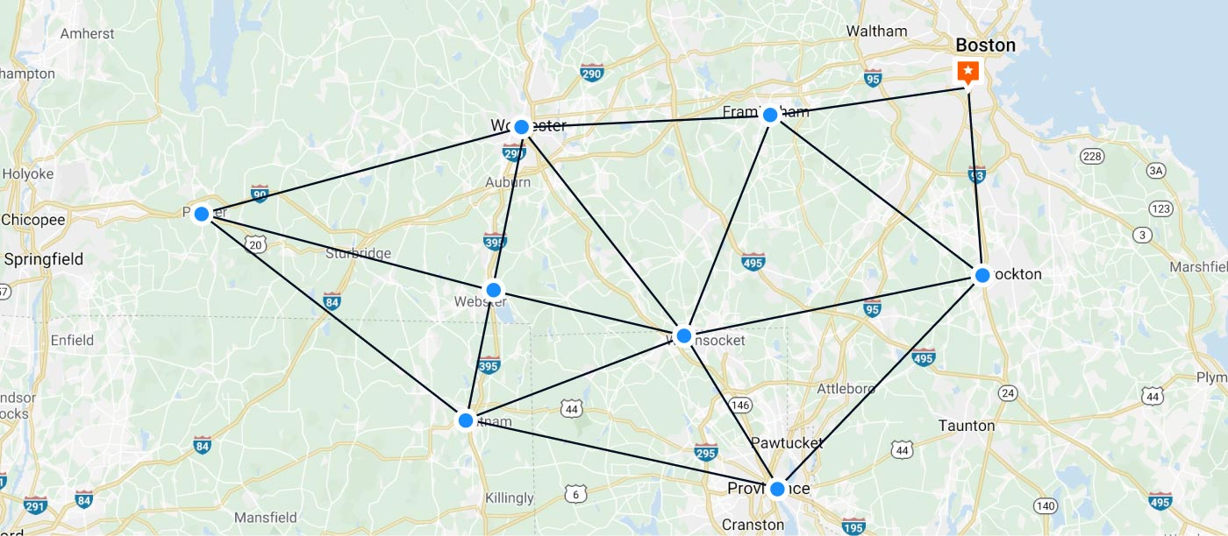

Visualising nodes and edges on the constructed graph

🛵B.R.A.S.R.✅ consists of 2 parts- Server and Client

git clone <https://github.com/sayashraaj/EXL.git>

cd Sayash-BRASR-EXL

Environment Variables/ Configuration Variables

Test keys have been embedded in the code for submission, privacy-free for test use

accessToken- generated and ready for test use by hackathon judges, configuration-free

Server Configuration

cd exl

npm install

node index

Client Configuration

cd gmap

npm install

npm start

🛵B.R.A.S.R.✅ How it works-

Is the best and most efficient way of solving the problem.

Using custom-built modifications on the age-old original Travelling Salesman Problem (TSP), which is considerably the most famous NP-hard problem, we have built the 🛵B.R.A.S.R.✅ algorithm

Solution Flow

User enters locations to visit, entering information in a simple form- clicks Save button

Form response is appended to a global array consisting of locations added so far

User clicks Show Schedule button, global array is sent as a JSON array of objects as body request to the Cross-Platform server

[

{

"id": "place0",

"coords": {

"lat": 51.51198245486377,

"lng": -0.1278277598563

},

"start": 0,

"end": 1000,

"z": 0

},

{

"id": "place1",

"coords": {

"lat": 51.503120589264064,

"lng": -0.15282095066100

},

"start": 0,

"end": 1000,

"z": 0

},

{

"id": "place2",

"coords": {

"lat": 51.503341807681544,

"lng": -0.11952824596429

},

"start": 0,

"end": 1000,

"z": 0

}

]

actual request.body sent to server

The Cross-Platform Modular Server parses the JSON array in the input parsing node

Server send an internal request to perform the calculative task using the 🛵B.R.A.S.R.✅ algorithm

* + Calculative function sends an external POST request to Time Travel Matrix API, obtaining information on least distance and time between each node
  + Parses external API response into an n x n matrix, n = number of nodes
  + Constructs a dense network as opposed to a sparse network of nodes
    - Number of edges = nC2 = n(n-1)/2 nodes
  + 🛵B.R.A.S.R.✅ algorithm runs on constructed dense network, returns object

Server reformats output as a union of request.body parameters and 🛵B.R.A.S.R.✅ output

JSON output

Server sends an internal request to ICS generating function

* External POST request sent, response obtained with necessary ICS configuration
* ICS calendar file generated

Server reformats output for ICS file obtained

ICS files can be imported, shared via email etc, and integrated with any modern calendar, including but not limited to Outlook, Teams, Google Calendar, Apple Calendar, Yahoo Calendar, etc.

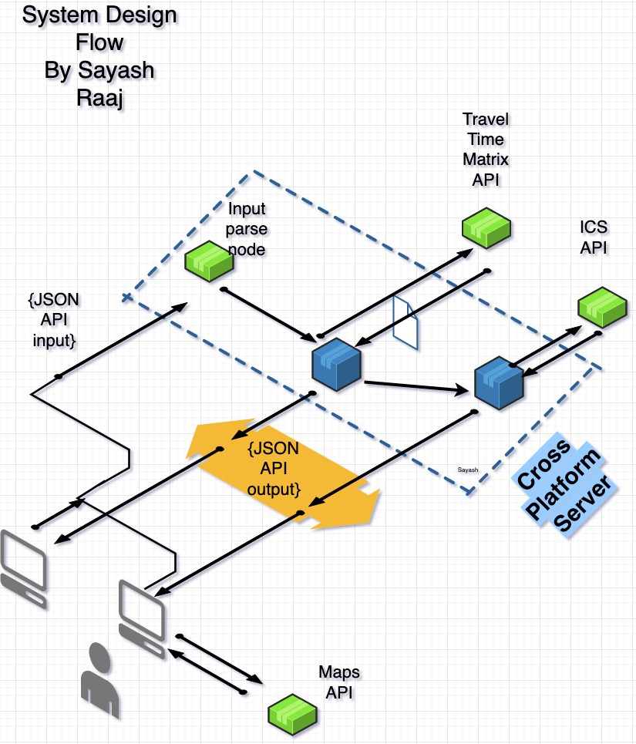

API Scheduling JSON Response

{

"ans": 3108,

"vec": [

{

"day": 0,

"name": "place0",

"start": "2022-07-02T13:18:09.862Z",

"end": "2022-07-02T13:18:09.862Z"

},

{

"day": 0,

"name": "place1",

"start": "2022-07-02T13:32:50.862Z",

"end": "2022-07-02T13:32:50.862Z"

},

{

"day": 1,

"name": "place0",

"start": "2022-07-03T13:18:09.862Z",

"end": "2022-07-03T13:18:09.862Z"

},

{

"day": 1,

"name": "place2",

"start": "2022-07-03T13:29:22.862Z",

"end": "2022-07-03T13:29:22.862Z"

}

]

}

API Calendar JSON Response

BEGIN:VCALENDAR

VERSION:2.0

PRODID:-//sebbo.net//ical-generator//EN

BEGIN:VEVENT

UID:d6b5eaf0-fb34-4994-8260-8486a2076c4a

SEQUENCE:0

DTSTAMP:20220702T172419Z

DTSTART:20220702T163217Z

DTEND:20220702T163217Z

SUMMARY:

LOCATION:Home

END:VEVENT

BEGIN:VEVENT

UID:68a6dfd7-6201-40d1-8262-5c0c2fc94445

SEQUENCE:0

DTSTAMP:20220702T172419Z

DTSTART:20220702T164658Z

DTEND:20220702T164658Z

SUMMARY:

LOCATION:Office

END:VEVENT

BEGIN:VEVENT

UID:fbcaafd2-4692-4d90-83ef-aabf99b909f1

SEQUENCE:0

DTSTAMP:20220702T172419Z

DTSTART:20220703T163217Z

DTEND:20220703T163217Z

SUMMARY:

LOCATION:Home

END:VEVENT

BEGIN:VEVENT

UID:26228bb1-4b4a-4422-ae1d-a2e300f01412

SEQUENCE:0

DTSTAMP:20220702T172419Z

DTSTART:20220703T164330Z

DTEND:20220703T164330Z

SUMMARY:

LOCATION:Shop

END:VEVENT

BEGIN:VEVENT

UID:fed62d25-7f47-46f2-bd4c-4a70b1ae2819

SEQUENCE:0

DTSTAMP:20220702T172419Z

DTSTART:20220704T163217Z

DTEND:20220704T163217Z

SUMMARY:

LOCATION:Home

END:VEVENT

BEGIN:VEVENT

UID:a54a8a43-09fb-4a77-bc39-775756c5909b

SEQUENCE:0

DTSTAMP:20220702T172419Z

DTSTART:20220704T164109Z

DTEND:20220704T164249Z

SUMMARY:

LOCATION:place3

END:VEVENT

END:VCALENDAR

UI integration

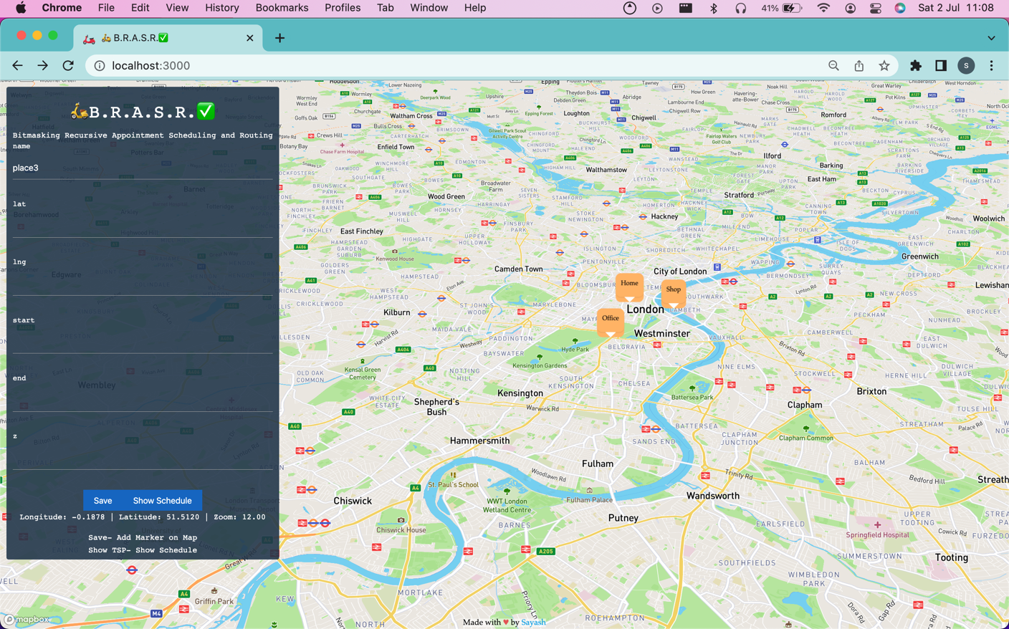

Maps integration displays all locations input by user

Home node is genesis node, first location input by user

No limit on number of nodes or locations

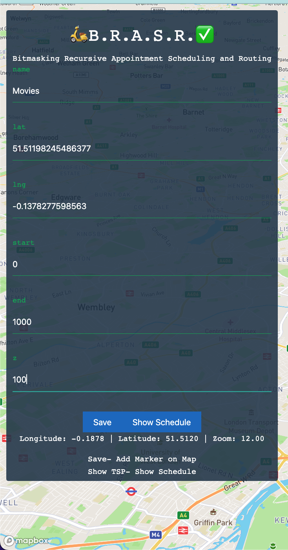

Input form- appending locations input by user- node creation at instant

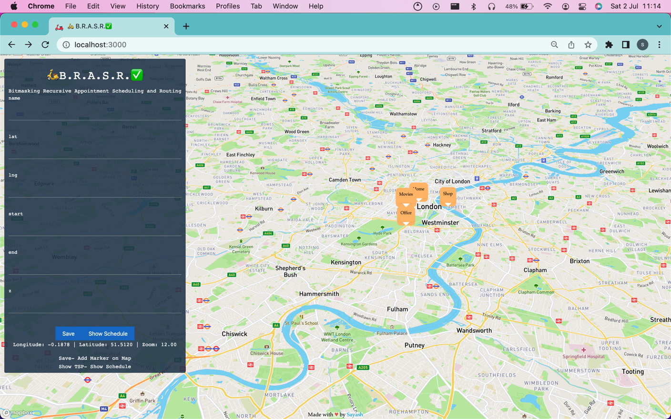

New node created and displayed, dynamic real-time Maps integration

